Wave Propagation Homework (32 Points)
(jas, Wave Propagation HW.docx, 11/20/2025)

Use units and clearly label answers using 3 or 4 significant digits where appropriate. Show your work so that if necessary partial credit can be awarded.

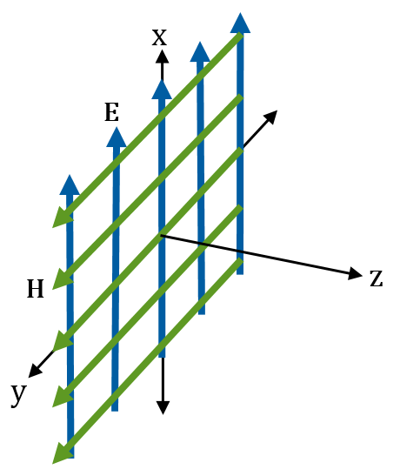
- The adjacent uniform plane wave traveling in the +z direction has electric and magnetic field vector values of E(x, y, z =0) = $\hat{x}$E_{x0} and H(x, y, z =0) = $\hat{y}$H_{y0} for all values of x and y. Determine each of the following values for this uniform plane wave at z = 0. Don’t worry about including units in this problem. (4 points total.)

E_{x} = $E_{x0}$ (0.5 points.)
E_{y} = 0 (0.5 points.)
E_{z} = 0 (0.5 points.)
H_{x} = 0 (0.5 points.)
H_{y} = $H_{y0}$(0.5 points.)
H_{z} = 0 (0.5 points.)
${∂E_{x}}/{∂x}=0$ (0.5 points.)
${∂H_{y}}/{∂y}=0$ (0.5 points.)

- An electromagnetic plane wave is traveling through pure water (ε_{r} = 81, µ_{r} = 1, σ = 0) in the +z direction with electric field given as $E\left(z,t\right)=\hat{x}\left(1.50\right)cos\left[2π\left(1 MHz\right)t-kz\right] \left(V/m\right)$. (14 points total.)

- Determine each of the following, including units: (8 points total.)

Phase Velocity - u_{p} = $\frac{c}{\sqrt{ϵ_{r}}}=\frac{3*{10}^{8}m/s}{\sqrt{81}}=3.33*{10}^{7}m/s$ (2 points.)
Wavelength - λ =$\frac{u_{p}}{f}=\frac{3.33*{10}^{7}m/s}{1*{10}^{6}Hz}=33.3 m$ (2 points.)
Wavenumber - k = $\frac{2π}{λ}=\frac{2π}{33.3m}=0.1885$ rad/s (2 points.)
Intrinsic Impedance – $η$ = $\sqrt{\frac{μ}{ϵ}}=\sqrt{\frac{μ_{r}μ_{0}}{ϵ_{r}ϵ_{0}}}=\sqrt{\frac{1\left(4π*{10}^{-7}H/m\right)}{81(8.85*{10}^{-12}F/m)}}=41.87 Ω$ (2 points.)

- Using the previously determined values for $E\left(z,t\right) and η,$ write the complete expression for H(z, t) in terms of numeric values, including units and a unit vector. (6 points.)
$$\left|H\left(z,t\right)\right|=\frac{E_{x0}^{+}}{η}=\frac{1.50 V}{41.84 Ω}=0.0358 A$$
$$H\left(z,t\right)= \hat{y}\left(0.0358\right)\cos\left[2π\left(1 MHz\right)t-0.1885z\right]A/m$$

- Using MATLAB, generate an m-file to produce a plot of skin depth versus frequency for a copper conductor assuming $μ_{r}=1, and σ=5.8×{10}^{7}S/m,$using the following expression for skin depth for good conductors: $δ_{s}=1/{\sqrt{πfμσ}}.$ Use the logspace() command to generate a logarithmic frequency vector ranging from 1 Hz to 10 GHz, consisting of 2000 points. Use the loglog()command to plot skin depth in millimeters (mm) on the y-axis, with scaling necessary to arrive at mm instead of meters. Include the title shown below ending with your name, x-axis label, and y-axis label as shown in the plot below. Replace the plot below with your version. (6 points.)
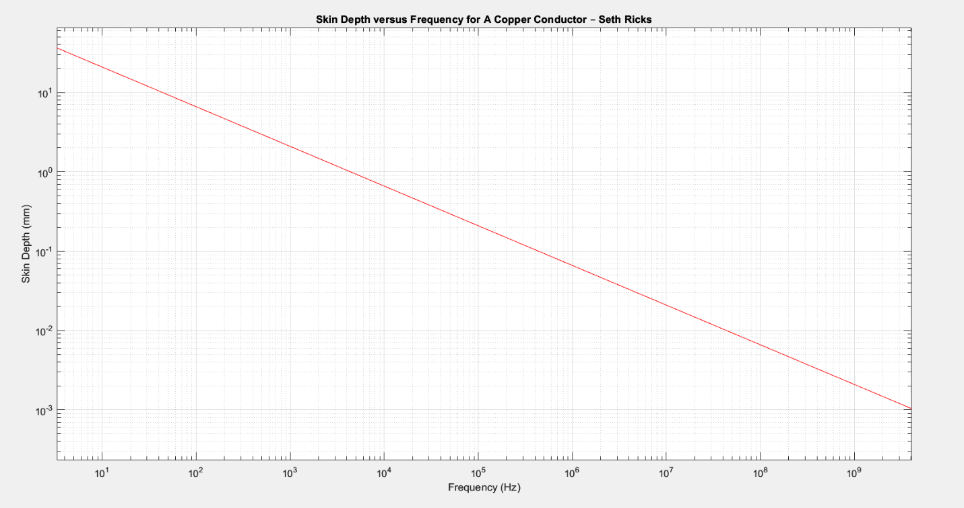

- Using MATLAB, generate an m-file to produce a plot of dB power ratio (10log₁₀(Ratio)), and dB voltage ratio (20log₁₀(Ratio)). Use the logspace() command to generate a logarithmic Ratio vector ranging from 10⁻² to 10⁶, consisting of 2000 points. Use the semilogx() command to plot dB_Power ratio and dB_Voltage ratio versus Ratio. Include the title shown below ending with your name, x-axis label, y-axis label and legend as shown in the plot below. Replace the plot below with your version. (8 points.)
